MAKE SKILLED IoT INTERNSHIP

ASSIGNMENT – 8

ARDUINO LOGICAL THINKING TASK

IF ANY OBJECT IS DETECTED ,ROBOT SHOULD MOVE EITHER RIGHT OT LEFT

* + HERE WE WILL BE USING ARDUINO INTERFACE.
  + COMPONENTS REQUIRED:
  1. ARDUINO UNO BOARD
  2. PC / LAPTOP INSTALLED WITH ARDUINO IDE SOFTWARE
  3. ULTERSONIC SENSOR
  4. MOTORS
  5. L293D DRIVERS
  6. JUMPING WIRES
* CIRCUIT DIAGRAM

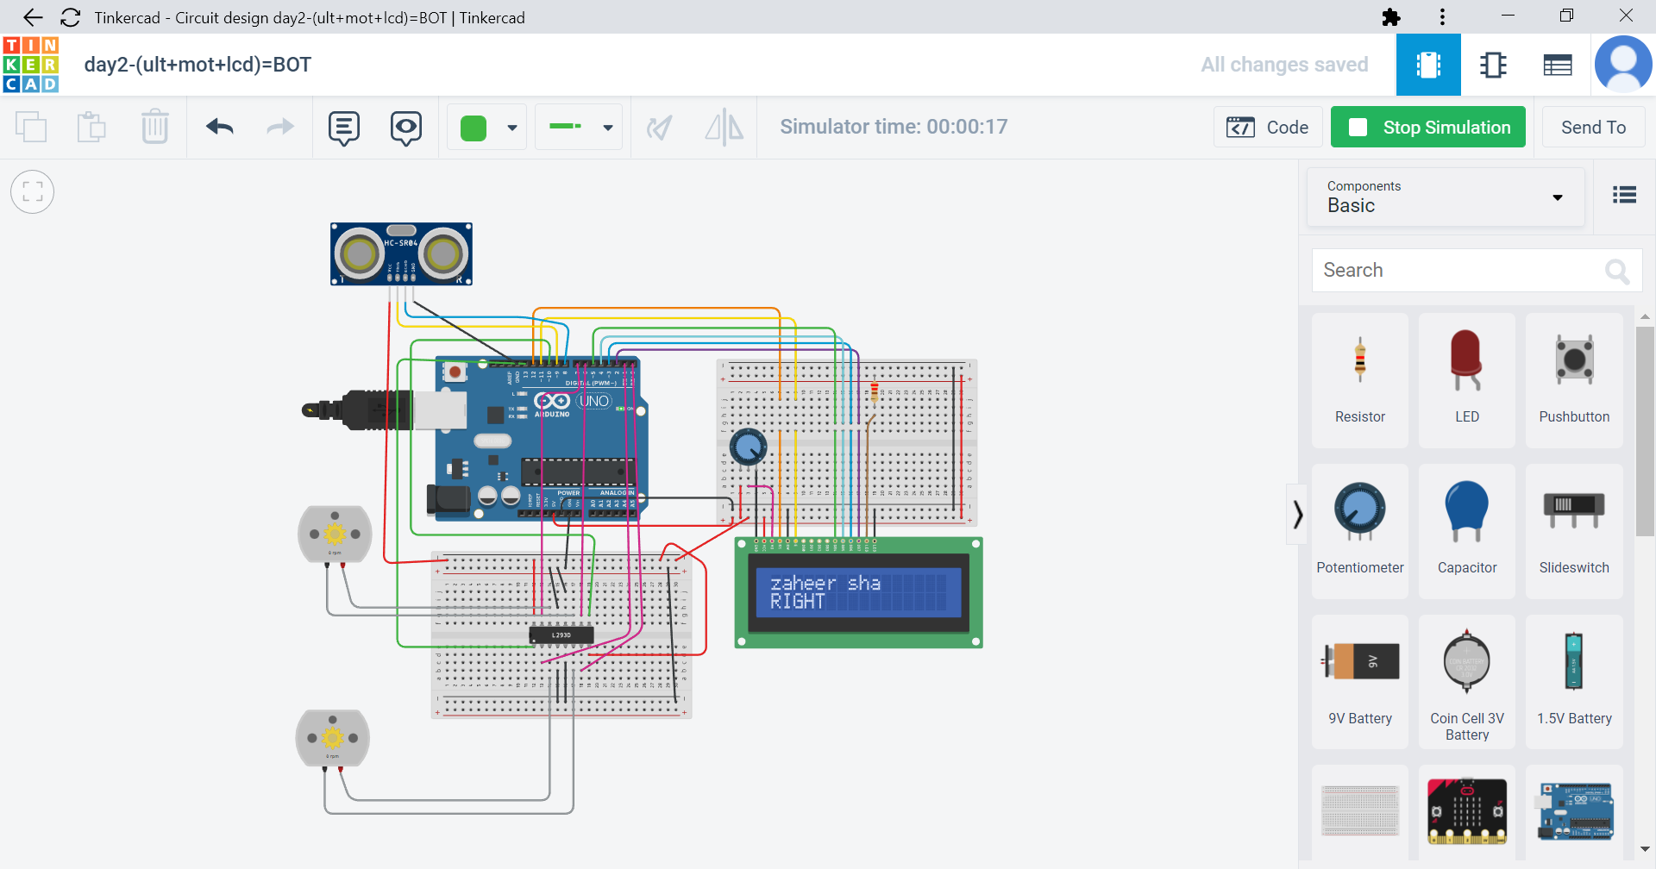

* PROGRAM

#include <LiquidCrystal.h>

int trigPin = 9;

int echoPin = 8;

int in_1 = 1;

int in_2 = 0;

int in_3 = 6;

int in_4 = 7;

int en1 = 2;

int en2 = 4;

float duration_us, distance_cm;

LiquidCrystal lcd_1(12, 11, 5, 4, 3, 2);

void setup()

{

Serial.begin (9600);

pinMode(in_1,OUTPUT) ;

pinMode(in_2,OUTPUT) ;

pinMode(in_3,OUTPUT) ;

pinMode(in_4,OUTPUT) ;

pinMode(trigPin, OUTPUT);

pinMode(echoPin, INPUT);

lcd_1.begin(16, 2);

lcd_1.print("zaheer sha");

}

void loop()

{

digitalWrite(en1, HIGH);

digitalWrite(en2, HIGH);

digitalWrite(trigPin, HIGH);

delayMicroseconds(10);

digitalWrite(trigPin, LOW);

duration_us = pulseIn(echoPin, HIGH);

distance_cm = 0.017 * duration_us;

Serial.print("distance: ");

Serial.print(distance_cm);

Serial.println(" cm");

delay(1000);

if (distance_cm > 70)

{

digitalWrite(in_1,HIGH) ;

digitalWrite(in_2,LOW) ;

digitalWrite(in_3,HIGH) ;

digitalWrite(in_4,LOW) ;

Serial.println("froward");

lcd_1.setCursor(0, 1);

lcd_1.print("FORWARD");

}

else if (distance_cm < 70 and distance_cm > 35 )

{

digitalWrite(in_1,LOW) ;

digitalWrite(in_2,HIGH) ;

digitalWrite(in_3,LOW) ;

digitalWrite(in_4,HIGH) ;

Serial.println("BACKWARD");

lcd_1.setCursor(0, 1);

lcd_1.print("BACKWARD");

delay(3000);

digitalWrite(in_1,HIGH) ;

digitalWrite(in_2,LOW) ;

digitalWrite(in_3,LOW) ;

digitalWrite(in_4,LOW) ;

Serial.println("RIGHT");

lcd_1.setCursor(0, 1);

lcd_1.print("RIGHT ");

}

}

**By Team : AKULA ZAHEER SHA , TAUFEEQ BASHA & QUIZER SHAH**